Ctrl + L to clear console section of chrome inspect
Number dt
- in js has a limit and if the limit is crossed then the number get round off to the nearest interger number while remaining in the limit
Operation
- A+B
Wher A,B=operand
And + is operator
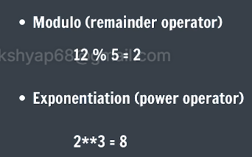
- When the whole no.s are calculated and output are decimal then the output does not remain integer but show the original output in decimal ex:5/2=2.5

